Галочкин М.В.

Первым делом было отредактированы файлы Excel для корректного экспорта данных, которые находятся в корневой папке.

Далее были созданы и заполнены таблицы со всеми ограничениями, диаграмма которых прикреплена ниже.

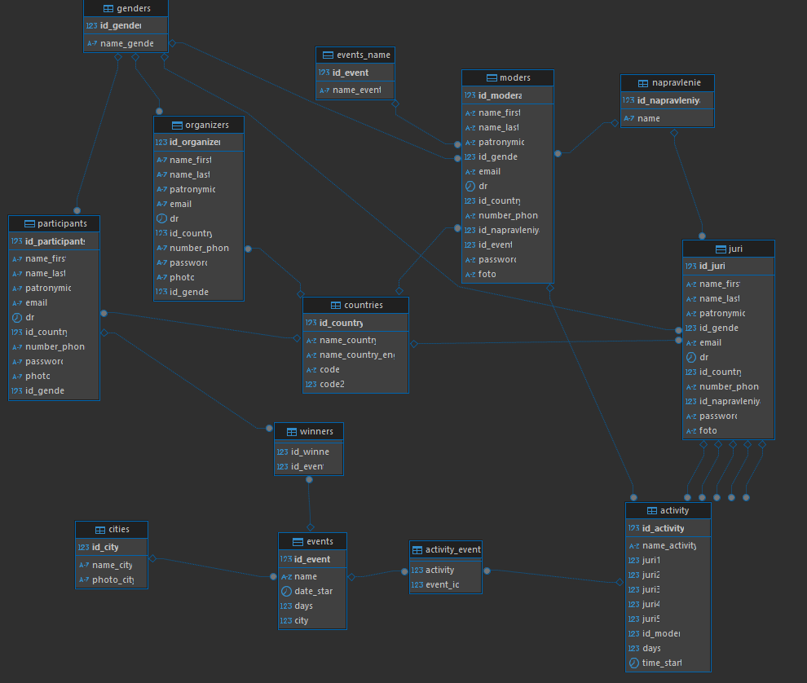

Заполненные таблицы:

Activity:

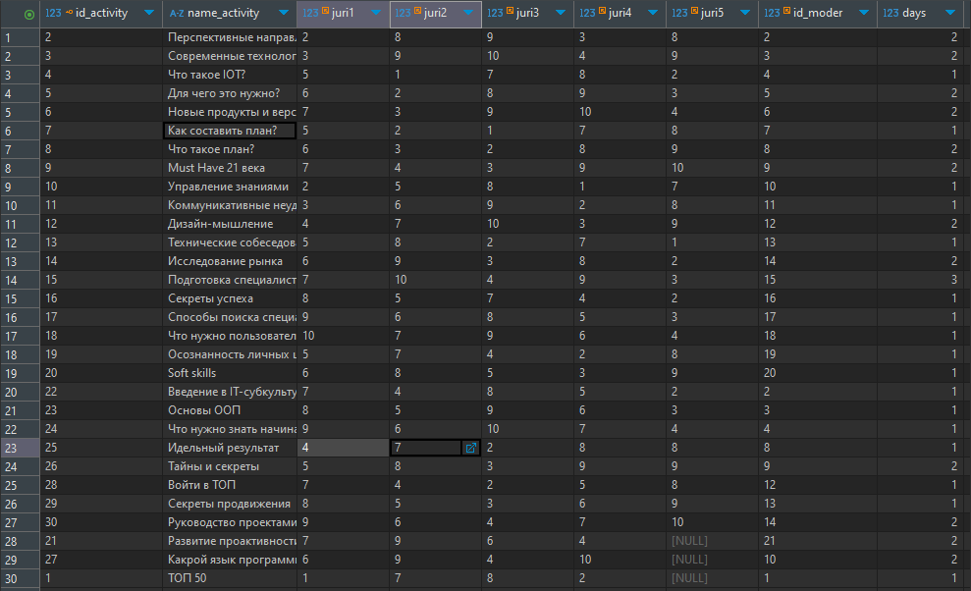

Activity_event:

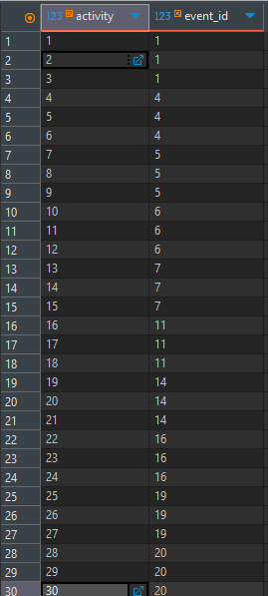

Cities:

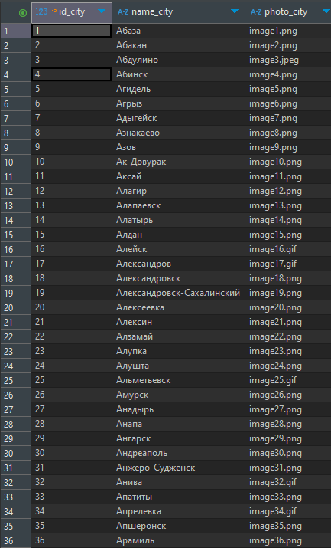

Countries:

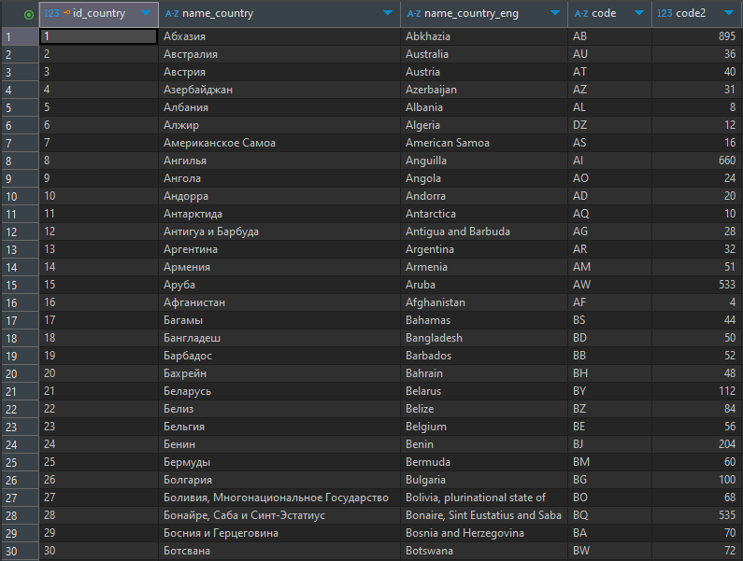

Events:

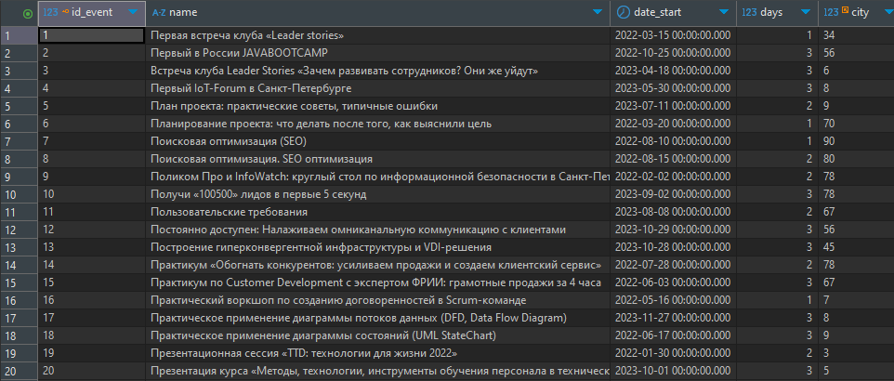

Events_name:

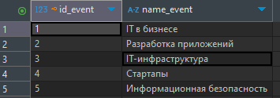

Genders:

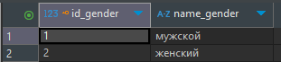

Juri:



Moders:

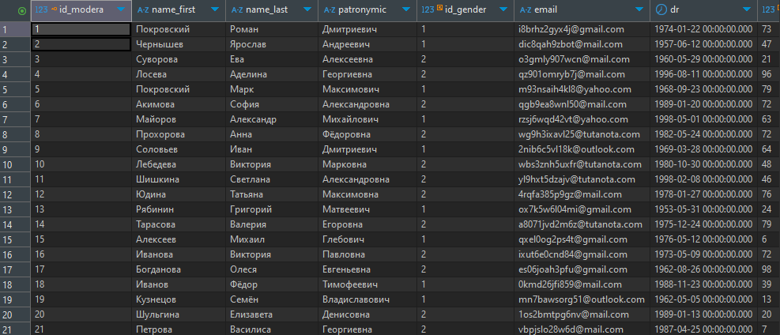

Napravlenie:

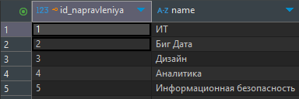

Organizer:

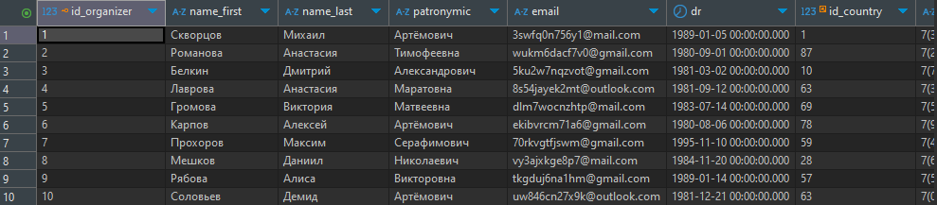

Participants:

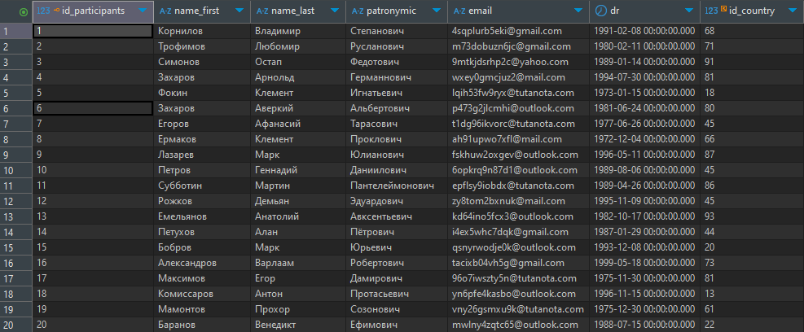

Events:

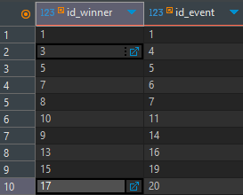

Скрипт БД:

|  |
| --- |
| **create** **table** Countries(  id_country **int** **primary** **key**,  name_country **text** **not** **null**,  name_country_eng **text** **not** **null**,  code **varchar**(5) **not** **null**,  code2 **int** **not** **null**  )  **create** **table** Cities(  id_city **int** **primary** **key**,  name_city **text** **not** **null**,  photo_city **text**  )  **create** **table** Genders(  id_gender **int** **primary** **key**,  name_gender **varchar**(10) **not** **null**  )  **create** **table** Napravlenie(  id_napravleniya **int** **primary** **key** **not** **null**,  **name** **text** **not** **null**  )  **create** **table** Events(  id_event **int** **primary** **key** **not** **null**,  **name** **text** **not** **null**,  date_start **timestamp** **not** **null**,  days **int**,  city **int** **references** Cities(id_city)  )  **create** **table** Events_name(  id_event **int** **primary** **key** **not** **null**,  name_event **text** **not** **null**  )  **create** **table** Participants(  id_participants **int** **primary** **key**,  name_first **text** **not** **null**,  name_last **text** **not** **null**,  patronymic **text** **not** **null**,  email **text** **not** **null**,  dr **timestamp** **not** **null**,  id_country **int** **references** Countries(id_country),  number_phone **text** **not** **null**,  **password** **text** **not** **null**,  photo **text** **not** **null**,  id_gender **int** **references** Genders(id_gender)  )  **create** **table** Organizers(  id_organizer **int** **primary** **key**,  name_first **text** **not** **null**,  name_last **text** **not** **null**,  patronymic **text** **not** **null**,  email **text** **not** **null**,  dr **timestamp** **not** **null**,  id_country **int** **references** Countries(id_country),  number_phone **text** **not** **null**,  **password** **text** **not** **null**,  photo **text** **not** **null**,  id_gender **int** **references** Genders(id_gender)  )  **create** **table** Juri(  id_juri **int** **primary** **key**,  name_first **text** **not** **null**,  name_last **text** **not** **null**,  patronymic **text** **not** **null**,  id_gender **int** **references** Genders(id_gender),  email **text** **not** **null**,  dr **timestamp** **not** **null**,  id_country **int** **references** Countries(id_country),  number_phone **text** **not** **null**,  id_napravleniya **int** **references** Napravlenie(id_napravleniya),  **password** **text** **not** **null**,  foto **text** **not** **null**  )  **create** **table** Moders(  id_modera **int** **primary** **key**,  name_first **text** **not** **null**,  name_last **text** **not** **null**,  patronymic **text** **not** **null**,  id_gender **int** **references** Genders(id_gender),  email **text** **not** **null**,  dr **timestamp** **not** **null**,  id_country **int** **references** Countries(id_country),  number_phone **text** **not** **null**,  id_napravleniya **int** **references** Napravlenie(id_napravleniya),  id_event **int** **references** Events_name(id_event),  **password** **text** **not** **null**,  foto **text** **not** **null**  )  **create** **table** Activity(  id_activity **int** **primary** **key**,  name_activity **text** **not** **null**,  juri1 **int** **references** Juri(id_juri),  juri2 **int** **references** Juri(id_juri),  juri3 **int** **references** Juri(id_juri),  juri4 **int** **references** Juri(id_juri),  juri5 **int** **references** Juri(id_juri),  id_moder **int** **references** Moders(id_modera),  days **int**,  time_start **time**  )  **create** **table** activity_event(  activity **int** **references** Activity(id_activity),  event_id **int** **references** Events(id_event)  )  **create** **table** winners(  id_winner **int** **references** Participants(id_participants),  id_event **int** **references** Events(id_event)  ) |